## FRED EXCEL Add-in Installation

1. Extract *fred* folder to your computer. You should not move this folder after you install the add-in.
2. Open Microsoft® Excel® and click on the *File* tab  in the upper left-hand corner of the window.
3. Choose  from the drop down menu, a window will appear.
4. On the left side of the window choose .
5. On the bottom of the window choose *Go.*  
6. In the new window, choose  and locate the file *fred.xlam* that you downloaded and click *OK.*
7. Ensure that the FRED add-in box is checked:  and click *OK.*
8. You may be prompted with a security warning. If so, select the allow Macro’s and data connections from the Add-in.
9. Close and re-open Excel to verify that the Add-in has been installed correctly.

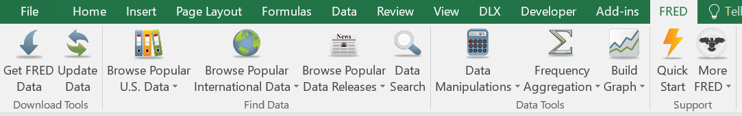

**Troubleshooting Installation**

* If you receive any of these warning or a similar warnings after installing the add-in

Security Warning Message Bar for macros

Message Bar with ActiveX warning message

Protected View from file validation failure

you need to change your Excel security settings. There are two options explained below:

Option 1: Add the *fred* folder as a “trusted location” (suggested).

Instructions can be found at <https://support.office.com/en-us/article/add-remove-or-change-a-trusted-location-7ee1cdc2-483e-4cbb-bcb3-4e7c67147fb4>.

Option 2: Enable all data connections.

Instructions can be found at <https://support.office.com/en-ie/article/block-or-unblock-external-content-in-office-documents-10204ae0-0621-411f-b0d6-575b0847a795>.

* If the add-in does not appear in the toolbar after restarting Excel, try the following:

<https://www.excelcampus.com/vba/add-in-ribbon-disappears/>